Semantic segmentation

Intro:

**Classification assigns a single class to the whole image whereas semantic segmentation classifies every pixel of the image to one of the classes.Hence Segmentation is different from Classification.**

Two popular applications of semantic segmentation include:

* **Self-driving vehicles:** These rely heavily on such segmented images to navigate through routes
* **Portrait mode on Google’s Pixel phone:** Here, instead of multiple classes, we need to classify every pixel as either belonging to the foreground or the background and then blurring the background part of the image

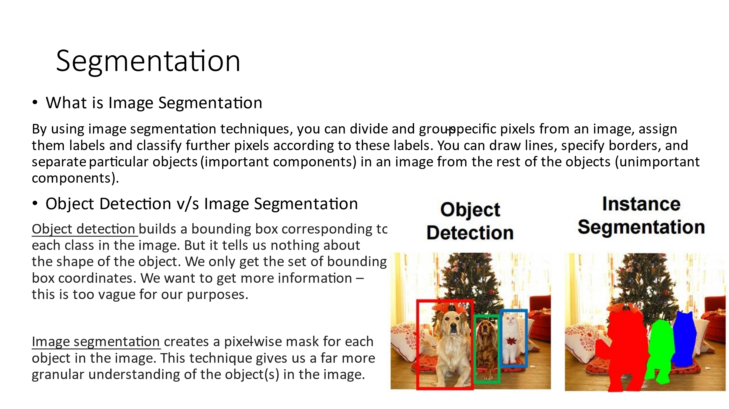

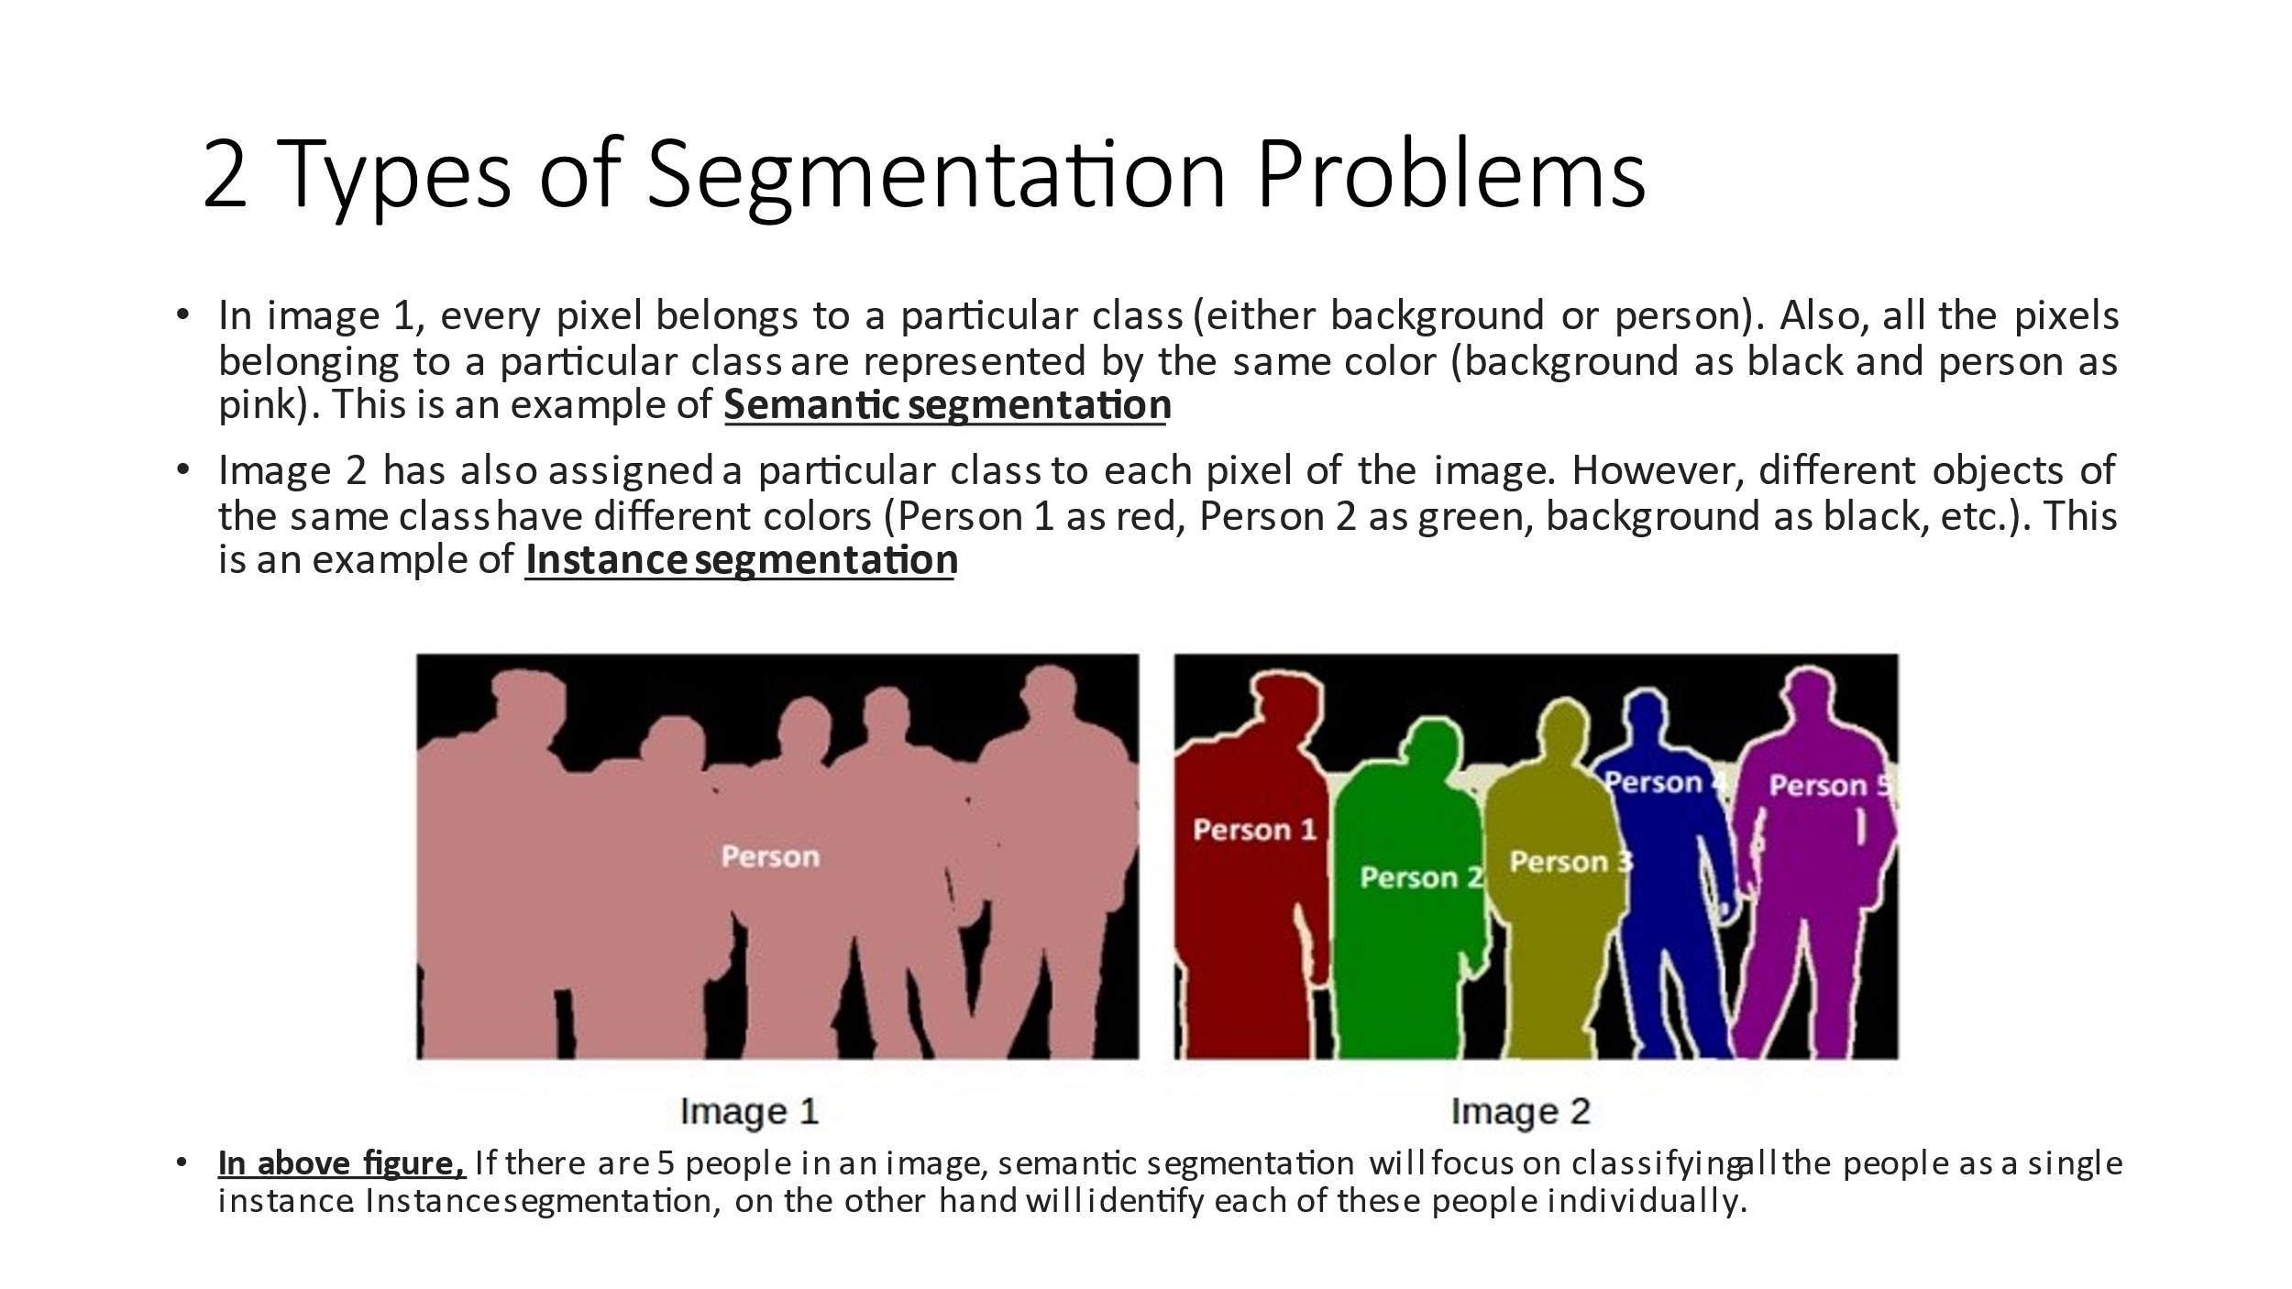

TRANSFORMERS (or) VISION TRANSFORMERS

Here for Image Processing we won’t use any Convolutional Network Layers. It works based on a standard transformer encoder to perform image processing tasks. Transformers doesn’t have any assumptions but CNN has a lot of assumptions about the image. In fact, Transformers are originally designed for NLP. I would recommend reading the [article](http://jalammar.github.io/illustrated-transformer/)by Jay Alammar.

**Using a transformer for image processing is more challenging (explained later)**, in NLP we pass a sequence of tokens as input but here we pass image patches as input, fitting an image to a transformer is really challenging, but in the paper, the image is divided into small patches and passed through the transformer.

It is a simple, scalable architecture, and performs state-of-art, especially when trained on large datasets such as JFT-300M. It’s also relatively cheap to pre-train the model. Transformers completely replaced LSTM in NLP.

**NOTE:** The Transformer is a model proposed in the paper “Attention Is All You Need” ([Vaswani et al., 2017](https://arxiv.org/abs/1706.03762)). It is a model that uses a mechanism called **self-attention**, which is neither a CNN nor an LSTM and builds a Transformer model to outperform existing methods significantly.

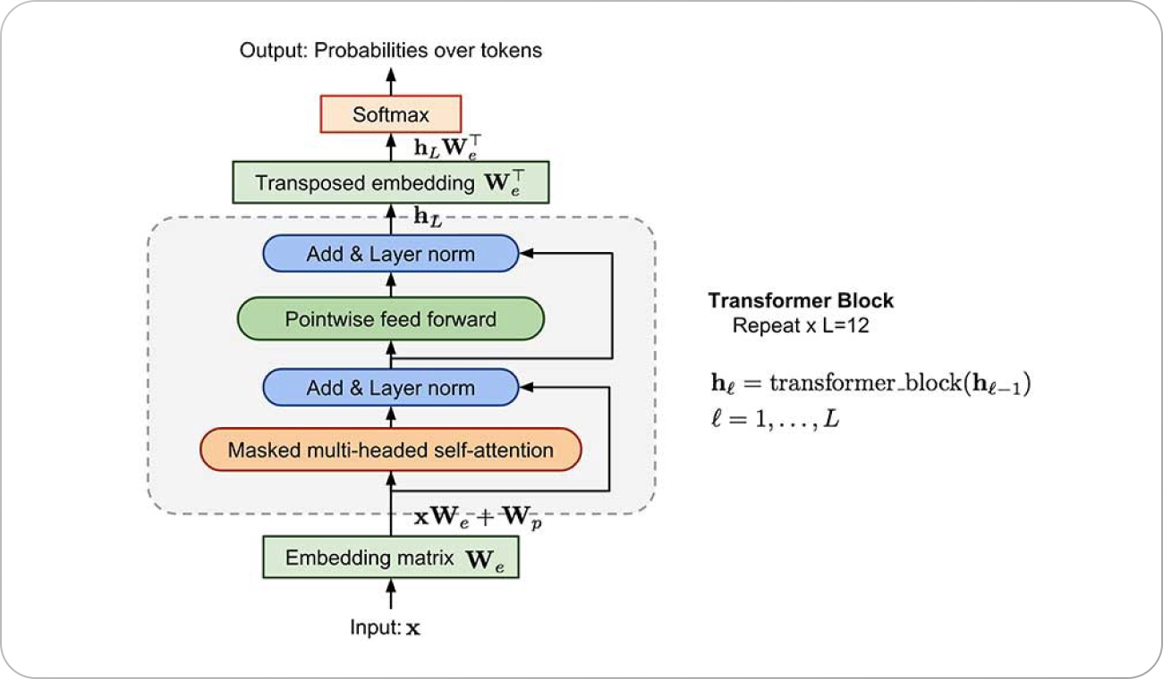

STEPS INSIDE A TRANSFORMER BLOCK:

1. TOKENIZATION: Conversion of a sentence to many constituent words.

Basics of NLP : Corpus, Tokens, and Engrams

**Corpus** consists of documents, documents comprise paragraphs, paragraphs comprise sentences and sentences comprise further smaller units which are called **Tokens.**

**Tokens** can be words, phrases, or Engrams, and Engrams are defined as the group of n words together.

For example, consider this given sentence-

“I love my phone.”

In this sentence,

the uni-grams(n=1) are: I, love, my, phone

Di-grams(n=2) are: I love, love my, my phone

And tri-grams(n=3) are: I love my, love my phone

So, uni-grams are representing one word, di-grams are representing two words together and tri-grams are representing three words together.

1. Vectorize : Word vectors are not just random numbers arranged as 1D vectors, they have some semantic meaning associated with it words which are of similar meanings or are closer to one another word in terms of the semantic meaning they tend to cluster up as vectors.

These vectors/numbers are what the NN can understand (as machine do Not understand images or human language words)

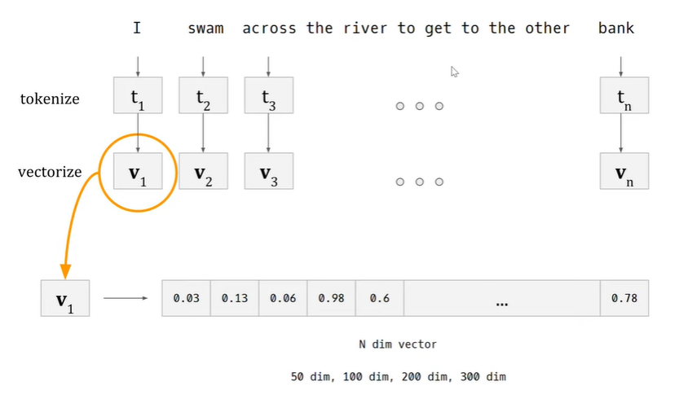

Consider an example of the word “bank” used in two different Context.

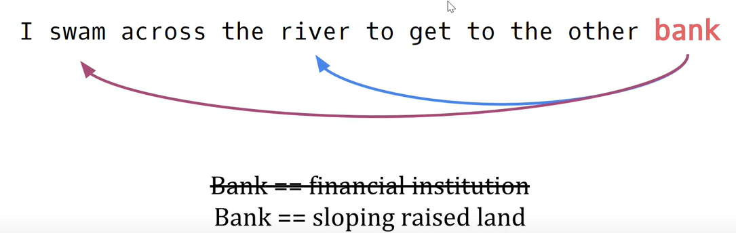

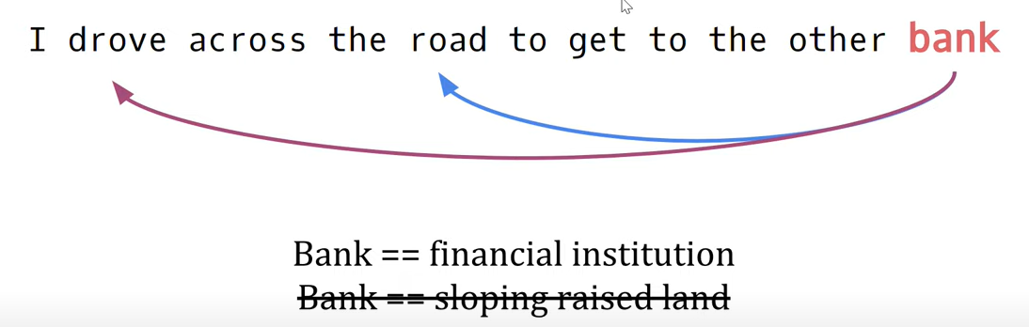

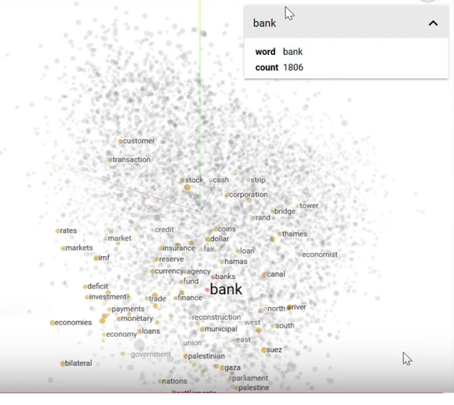

Fig: A representation of word Embeddings

***For Example: Word “bank” is closely associated with words such as “finance, fund, trade, canal” etc. Hence vectors of these words would be very closely oriented. Note that word “bank “ is already biased towards being money related or in the context of money. BUT, this can be changed to a different CONTEXT of say, Canals, by adding some more information as use of words like ”swam” and “river”. This is essentially what a Self-Attention Block does.***

**Note : Word Vectors (v1,v2…vn) are picked from “word vectorizers” or “Co-Occurrence Matrix”**

1. **What are Co-occurrence Matrices : -----**

Co-occurrence matrices are a fundamental concept in NLP, and we can use them to represent the relationship between elements in a text corpus. Usually, in NLP, we work with a collection of text or text corpus. Elements of text corpus can refer to sentences, words, phrases, or any other linguistic unit of interest.

With co-occurrence matrices, it is possible to represent these elements using rows and columns of a matrix. More precisely, each row and column of a matrix represents a unique element of a text corpus. Cells of the matrix represent the number of times two elements appear together in a predefined context.

**Example of Co-occurrence Matrices : -----**

As an example, let’s use three sentences below:

Apples are green and red.

Red apples are sweet.

Green oranges are sour.

Then, their Co-occurrence matrix would be:

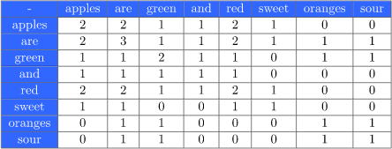

**What Are the Uses of Co-occurrence Matrices in NLP**

Basically, we can take any column (or, row since symmetric) from the co-occurrence matrix and represent it as a word embedding. [Word embeddings](https://www.baeldung.com/cs/word2vec-word-embeddings#types-of-word-embedding), which is a semantic representation of a word expressed with a numerical vector. Almost every NLP and machine learning algorithm requires a numerical vector(or, these word embeddings) as an input. Some applications include:

* Text classification
* [Topic modeling](https://www.baeldung.com/cs/latent-dirichlet-allocation#topic-modeling)

**NOTE:** One problem might be the high dimension of these wordvectors (say, in a situation where we have thousands of documents with lakhs of Unique words/elements. Thus each word/element would have a “wordvector” of size (lakh X 1), which is huge), but it can be solved using dimensional reduction techniques such as PCA (principal component analysis) or SVD (singular value decomposition) or even Transformer Encoder.

1. **TF-IDF Vectorizer :** Used to transform text into “meaningful” word vectors . (similar to above co-occurrence matrix)

TF-IDF is an abbreviation for Term Frequency Inverse Document Frequency (tf-idf). **tf-idf**value of a term in a document is the product of its tf and idf. The higher is the value, the more relevant the term is in that document.

***Term frequency*** *is defined as the number of times a word appears in a document divided by the total number of words in the document. Generally, known as Normalization in some sense.*

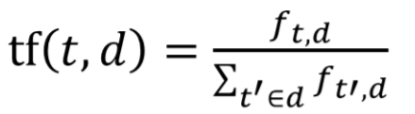

Term Frequency

***Inverse data frequency(idf)*** *defined as the log of the total number of documents divided by the number of documents that contain the word.*

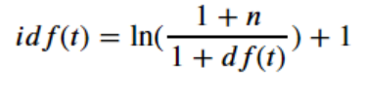

Inverse Document Frequency

TF-IDF defined as below :

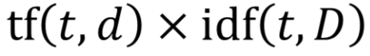

Example 1:

Doc1: The sky is blue.  
Doc2: The sun is bright.

Then we will get,

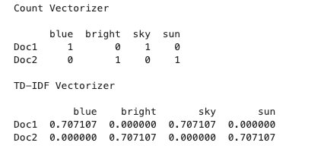

Example 2:

Consider the sentence "I like this car. It has GPS navigation. It price also very cheap." This has 3 sentences, to be treated as 3 documents for the purpose of calculating Tf-idf .

Consider the word “car” in the text for TF-IDF calculation.

**Calculation:**

Total number of words = 11

Consider 1st sentence ‘I like this car’ for Tf calculation .

TF=1/4=>0.25

Now, since a total of 3 documents and only 1 of them contains the word “car” in it. Thus, Idf is

IDF=log(3+1/1+1)=>1.308

Hence,

TF-IDF=0.25 * 1.308=>0.327

1. **Self Attention Mechanism/Block:**

A full overview of self-tension mechanism. The input that it takes are these word vectors (see above) and it weighs word vectors according to the context of that word then it provides contextualized representation of vectors.

So, from above example of 2 sentences with the word “bank”, if your word bank is just extracted as a word vector it may be closer to financial institutions and things related to money but after you have added other context in the sentence your contextualized representation of this vector might be closer to water bodies like rivers and canals. This is what the self-tension mechanism is actually doing

Hence,

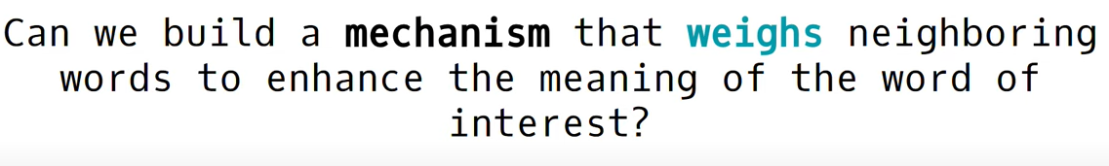

This Mechanism is called ATTENTION mechanism and it allows us to look around the entire sentence to establish the context of the word (ex: “bank” in above example).

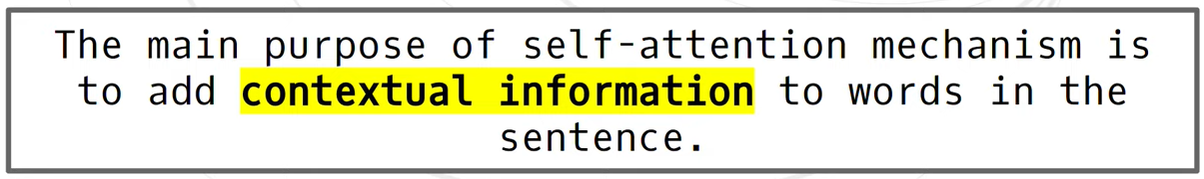

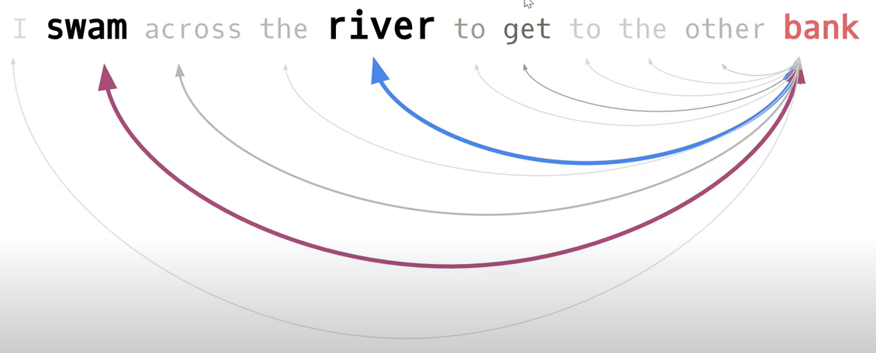

Thus, we have from steps 1,2 and 3.

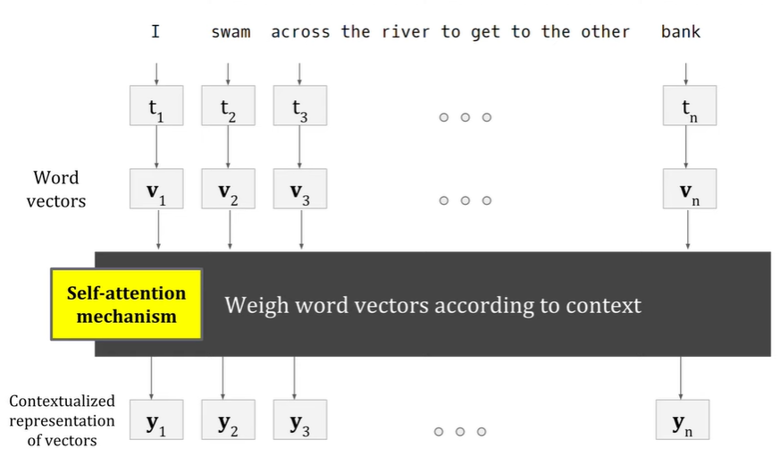

BASIC MATHS: The DOT Product

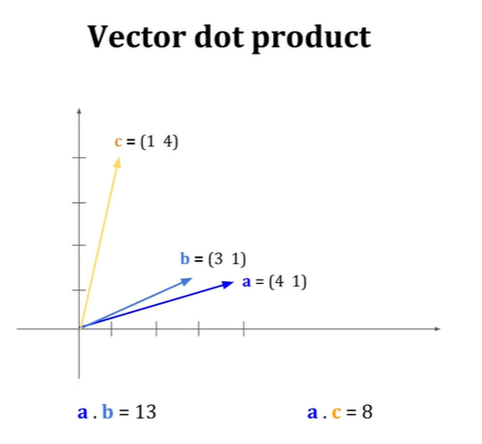

Consider the vectors a,b,c. We can say that a and b are pretty similar since they are closer so they're similar so if you do a dot product between vector a and b you're going to have a magnitude which is larger than if you do a dot product between vector a and c so that is the essence of a vector dot product

**Steps inside a Self Attention Mechanism:**

1. Get Dot product:

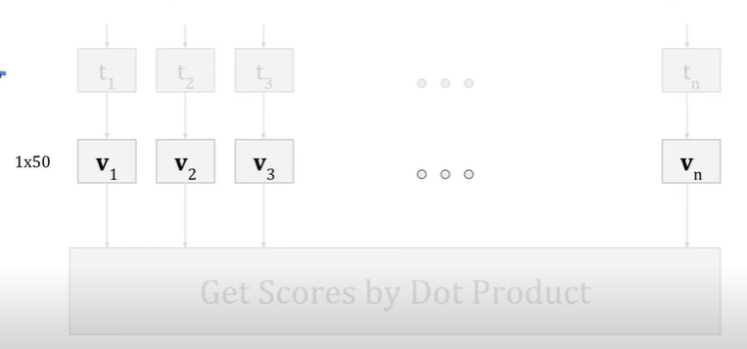

Now we're going to do dot product is we're going to do dot product for every pair possible including itself. So first we're going to find a dot product between vector v1 and itself so vector v1 is 1 by 50 and we have a transpose vector v1 so it becomes 50 by one so if you do a dot product we get a SCORE (denoted as S )

We're going to do the same for vector v1 and v2 same for vector v1 and v3 vector v1 and vn like this and we're going to do for every pair possible .

What we get is this:

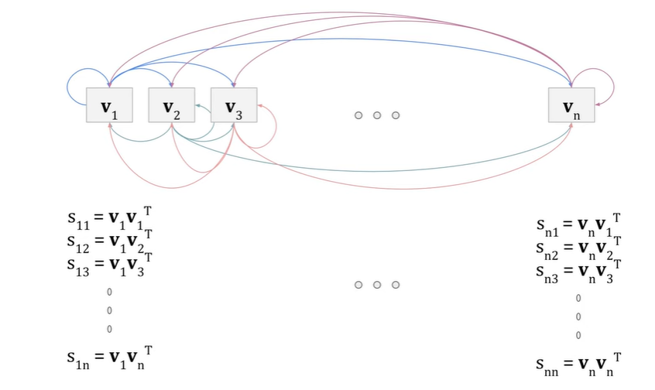

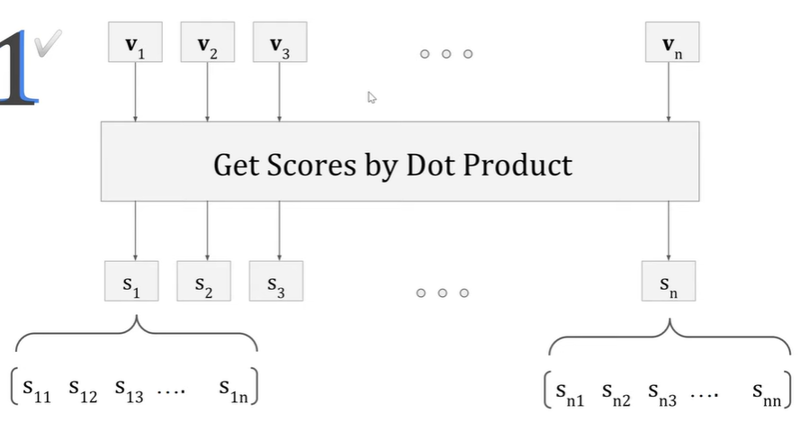

What it is we are doing is this word vector is trying to see which other word vector is close to itself and if they're close to one another their dot product is going to be big and their SCORE (i.e S ) is going to be big that is they have some form of agreement that is. The essence is that we're essentially trying to get the scores the higher the score the closer the meanings the higher the agreement between words. This is what will help identify the CONTEXT of the word.

1. Normalize wit Softmax and get weights (w) : To get probabilities so that sum of weights (ex: w11 to w1n) corresponding to each word is 1.

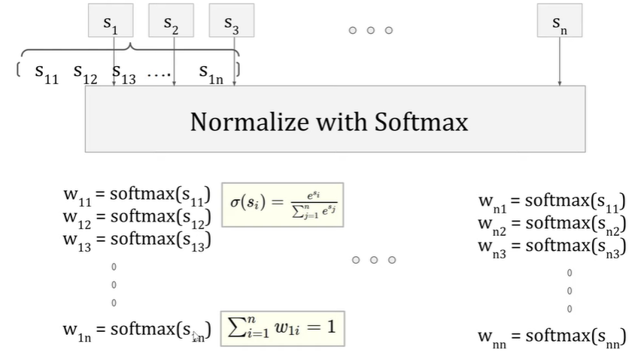

These weights(w1n to… w1n to… wn1) are going to be useful to weigh the original word vectors ( V1 to Vn)

1. **Weigh the Original Word Vectors with weights calculated:**

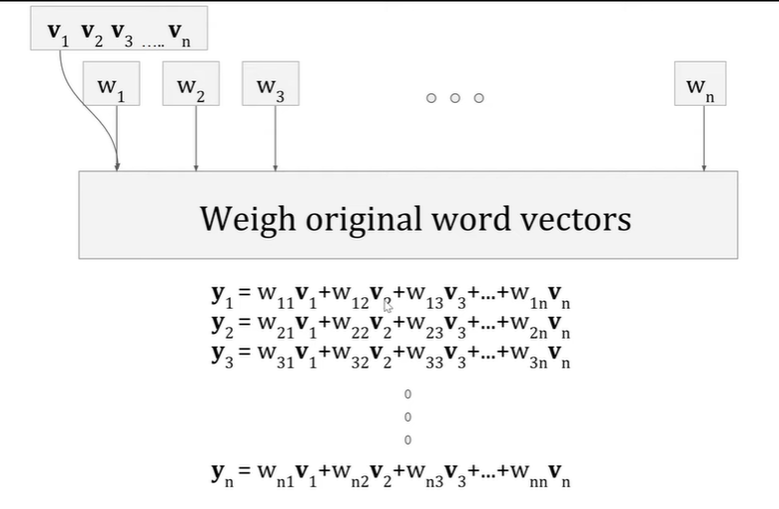

Consider this only,

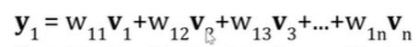

This y1 actually is the contextualized representation of v1. So you're going to take some weight(w11) from v1 which is yourself , then, you want some influence from v2 and the influence is defined by this weight(w12) and you want some influence for v3 that's defined by (w13) weight so on and so forth. So now your work vector is no longer pointing in the same direction as it was before. Now, it is pointing probably in a different direction. The vector is basically tugged and pulled to a direction where it is enhanced by its neighbors that is the beauty of it.

THUS SUMMARY OF STEPS 1,2,3,and 4 are:

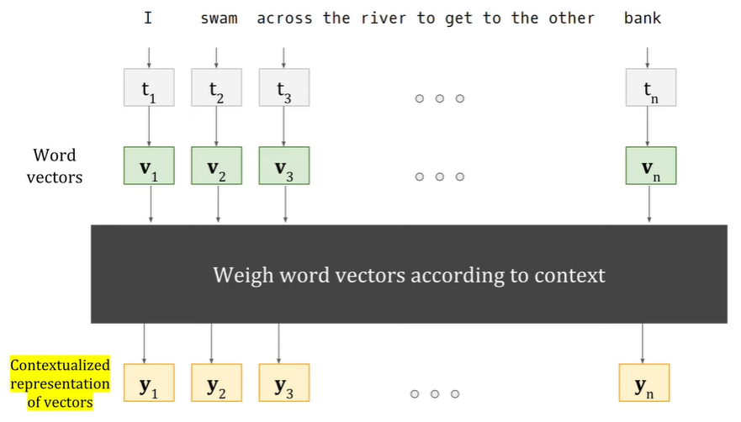

WHERE ARE THE “LEARNABLE WEIGHTS” or how is the NN Learning ??

NOTE: The beauty behind this self-tension mechanism it is using the same word vectors for keys(K), queries(q) and values(v).

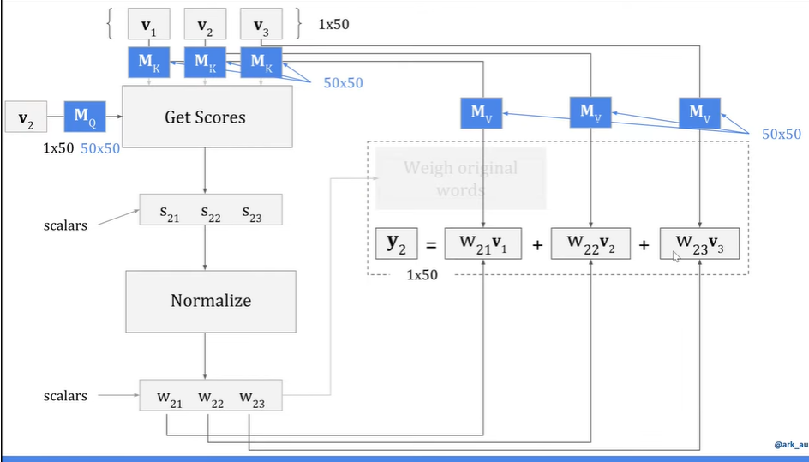

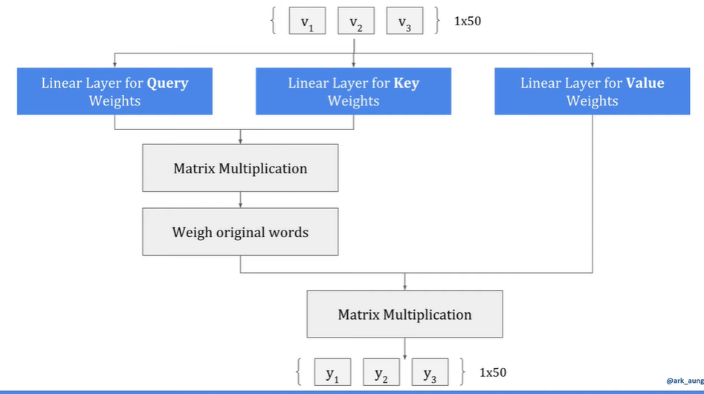

Both Fig above are essentially exactly same.

Adding a Scaling operation :

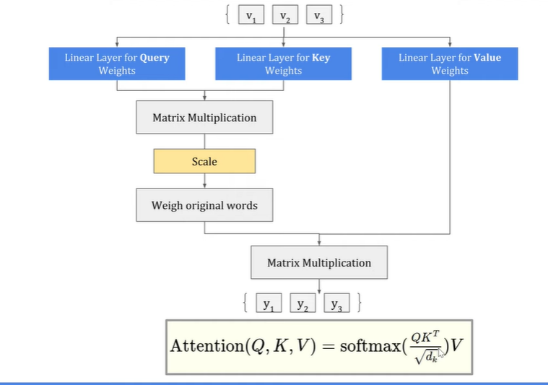



FIG: *A demo of a Vision Transformer for Image Classification*

**Encoder Model:**

Encoder models use only the encoder of a Transformer model. At each stage, the attention layers can access all the words in the initial sentence. These models are often characterized as having “bi-directional” attention, and are often called *auto-encoding models*.

**The pretraining/training** of these models usually revolves around somehow corrupting a given sentence (for instance, by masking random words in it) and tasking the model with finding or reconstructing the initial sentence.

Encoder models are best suited for tasks requiring an understanding of the full sentence, such as sentence classification, named entity recognition (and more generally word classification), and extractive question answering.

Representatives of this family of models include:

* [ALBERT](https://huggingface.co/transformers/model_doc/albert.html), [BERT](https://huggingface.co/transformers/model_doc/bert.html), [DistilBERT](https://huggingface.co/transformers/model_doc/distilbert.html), [ELECTRA](https://huggingface.co/transformers/model_doc/electra.html), [RoBERTa](https://huggingface.co/transformers/model_doc/roberta.html)

NOTE:

[**Why do all auto-encoders downsample?**](https://forums.fast.ai/t/why-do-all-auto-encoders-downsample/52930)

Yes, all Encoders usually downsample. In fact, it is one of the primary reasons for using Encoders.

**Reason**: If a neural network is forced to give correct outputs with a reduced representation of the data, it will eventually learn to ignore the unimportant parts of the data and only focus on the parts that help it reduce the loss (i.e. give correct predictions).

**Decoder Model:**

Decoder models use only the decoder of a Transformer model. At each stage, for a given word the attention layers can only access the words positioned before it in the sentence. These models are often called *auto-regressive models*.

**The pretraining/Training** of decoder models usually revolves around predicting the next word in the sentence.

These models are best suited for tasks involving text generation.

Representatives of this family of models include:

* [CTRL](https://huggingface.co/transformers/model_doc/ctrl.html), [GPT](https://huggingface.co/docs/transformers/model_doc/openai-gpt), [GPT-2](https://huggingface.co/transformers/model_doc/gpt2.html), [Transformer XL](https://huggingface.co/transformers/model_doc/transfo-xl.html)

**Architectures vs. checkpoints**

As we dive into Transformer models in this course, you’ll see mentions of *architectures* and *checkpoints* as well as *models*. These terms all have slightly different meanings:

* **Architecture**: This is **the skeleton of the model** — the definition of each layer and each operation that happens within the model.
* **Checkpoints**: These are **the weights** that will be loaded in a given architecture.
* **Model**: This is an umbrella term that isn’t as precise as “architecture” or “checkpoint”: it can mean both. This course will specify *architecture* or *checkpoint* when it matters to reduce ambiguity.

For example, BERT is an architecture while bert-base-cased, a set of weights trained by the Google team for the first release of BERT, is a checkpoint. However, one can say “the BERT model” and “the bert-base-cased model.”

**The Transformer architecture : The original architecture**

The Transformer architecture was originally designed for translation.

**During training,** the encoder receives inputs (sentences) in a certain language, while the decoder receives the same sentences in the desired target language. In the encoder, the attention layers can use all the words in a sentence (since, as we just saw, the translation of a given word can be dependent on what is after as well as before it in the sentence). The decoder, however, works sequentially and can only pay attention to the words in the sentence that it has already translated (so, only the words before the word currently being generated). For example, when we have predicted the first three words of the translated target, we give them to the decoder which then uses all the inputs of the encoder to try to predict the fourth word.

To speed things up during training (when the model has access to target sentences), the decoder is fed the whole target, but it is not allowed to use future words (if it had access to the word at position 2 when trying to predict the word at position 2, the problem would not be very hard!). For instance, when trying to predict the fourth word, the attention layer will only have access to the words in positions 1 to 3.

The original Transformer architecture looked like this, with the encoder on the left and the decoder on the right:

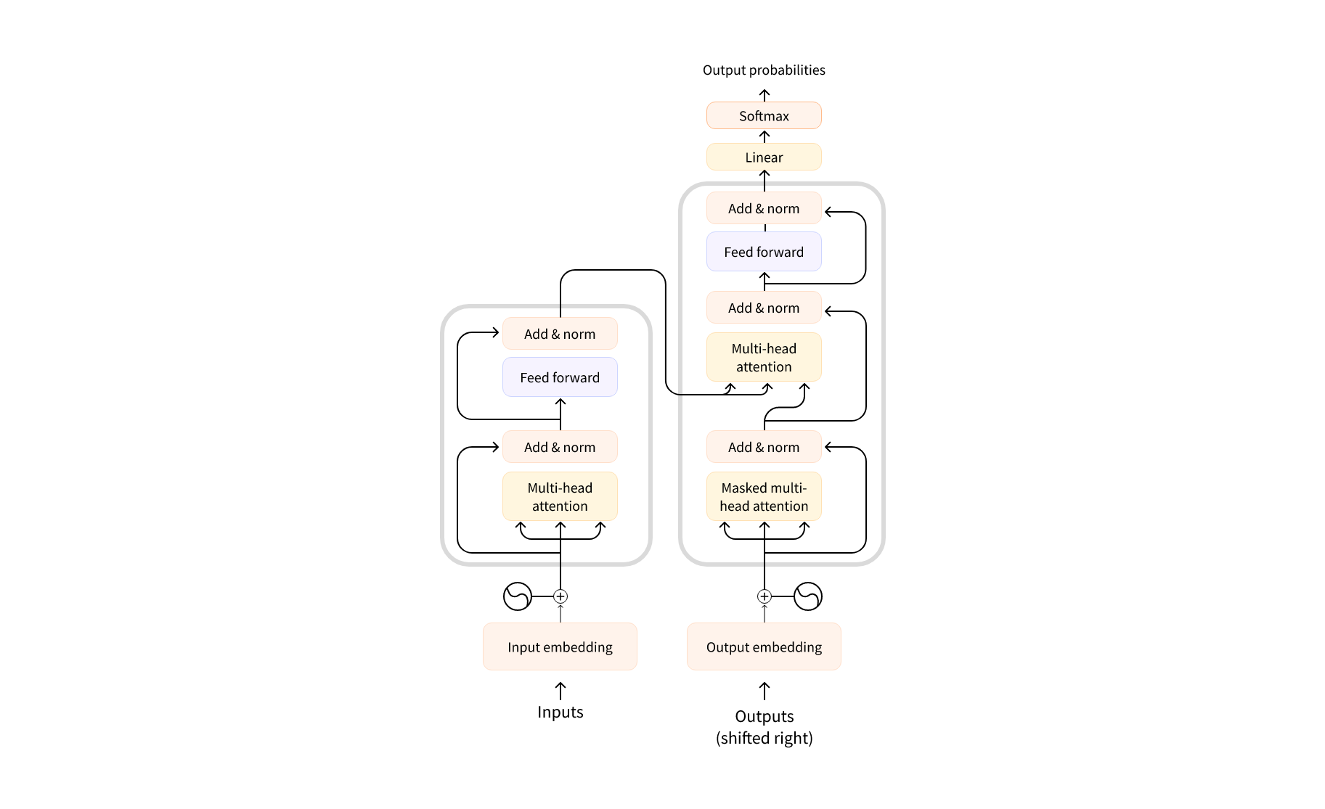

Note that the first attention layer in a decoder block pays attention to all (past) inputs to the decoder, but the second attention layer uses the output of the encoder. It can thus access the whole input sentence to best predict the current word. This is very useful as different languages can have grammatical rules that put the words in different orders, or some context provided later in the sentence may be helpful to determine the best translation of a given word.

* 1. Computational Power of “Depthwise Separable” Convolution

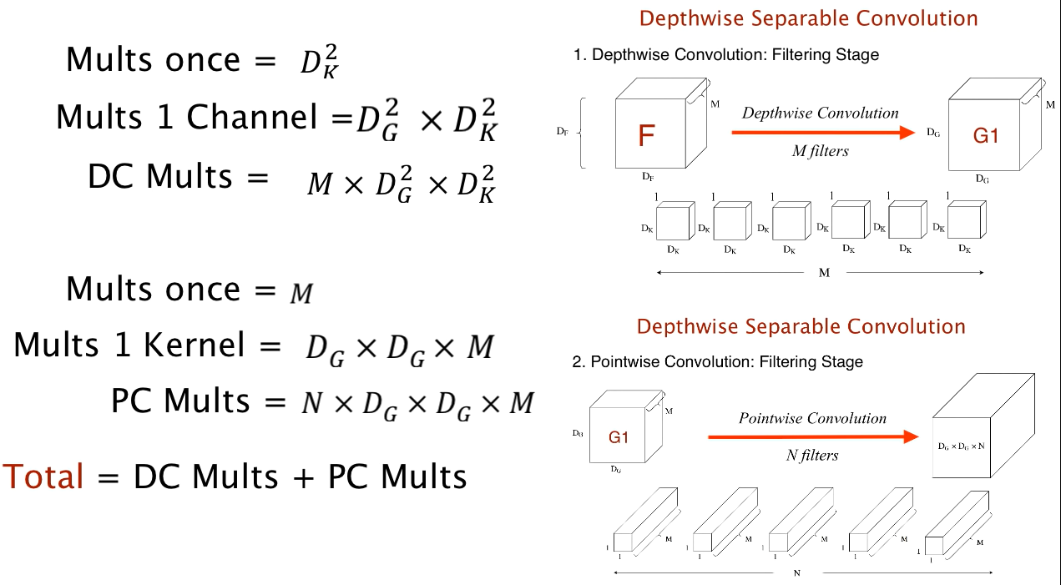

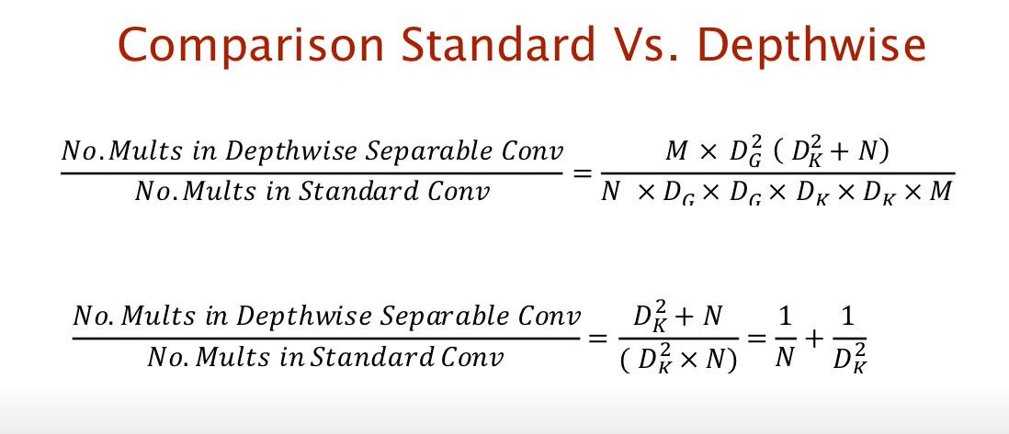

Example: N =1024, filter size = 3X3, THEN (from below) we can say that Standard Conv has 9 times more multiplication operation than Depthwise convolution.

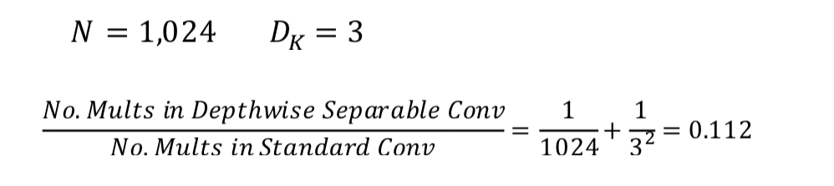

NOTES FOR SEAFORMER RESEARCH PAPER:

1. **Auto encoders are used for Dimensionality Reduction**. (Dimensionality Reduction is simply reducing the dimensions of the input image/text by extracting only the necessary/relevant features from the entire input.)

AutoEncoder is an unsupervised Artificial Neural Network that attempts to encode the data by compressing it into the lower dimensions (bottleneck layer or code) and then decoding the data to reconstruct the original input. The bottleneck layer (or hidden layer or code) holds the compressed representation of the input data.

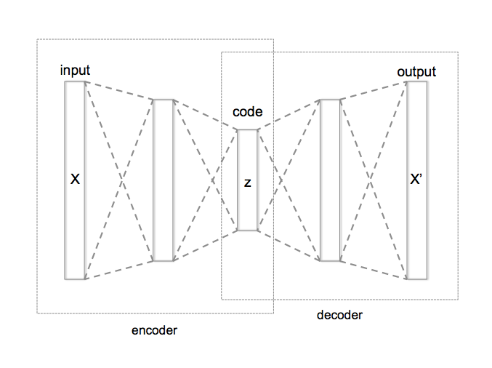

Explanation for Dimensionality Reduction : We are able to reduce the Dimension using the first part i.e. Encoder part by reducing the number the neurons in each subsequent layer. And since wkt each neuron gives one output **(one output = one feature = same as one dimension**), thus, the number of dimensions goes on decreasing during Encoding.

NOTE: “backbone” = Encoder part of model & Encoder is used for Feature Extraction.

“light segmentation head” = Decoder part of model here & here it is just used for upsampling.

We basically categorize model components into 4 types.

* backbone: usually an FCN network to extract feature maps, e.g., ResNet, MobileNet.
* neck: the component between backbones and heads, e.g., FPN, PAFPN.
* head: the component for specific tasks, e.g., bbox prediction and mask prediction.
* roi extractor: the part for extracting RoI features from feature maps, e.g., RoI Align

1. MobileNetV2 : MobileNet here is used for feature extraction. Mobilenet as a backbone can achieve fast object detection optimized for mobile devices. MobileNetV2 [2] introduces a new CNN layer, the inverted residual and linear bottleneck layer, enabling high accuracy/performance in mobile

This class of models is based on a simplified architecture that uses depth-separable convolutions(see 2 pages above in this document) to build lightweight deep neural networks. It decomposes standard convolution into **depth convolution** and a 1×1 convolution known as **point convolution**. A standard convolution has one step for both filtering and combining the inputs into a new set of outputs. But the depth-separable convolution splits it into two layers, a separate layer for filtering and a separate layer for combining. This factorization drastically reduces the computation and model size.

1. Contextual Branch: Context can be formulated in terms of semantic compatibility relations between one object and its neighboring objects or image patches (stuff), in which a compatibility relation is an indication of the co-occurrence of visual patterns. For example, a car is likely to appear over a road, and a glass is likely to appear over a table. Context can also encode incompatibility relations. For example, a boat is unlikely to appear on a road.
2. Spatial Branch: Space represents the 2D plane(x, y) in images. Thus, Spatial information in CNN for example in the first convolutional layer, extracts low-level features like edges, corners, etc. and in the later Convolutional layer it extracts spatial information like eyes, nose, etc. This is spatial information in images. CNN's don't maintain the spatial relationships among features
3. Fusion block to fuse the features in the context branch into the spatial branch, bringing high-level semantic information into the low-level spatial information. Then, the semantics weights from context branch are element-wisely multiplied to the high resolution feature from spatial branch
4. DataSet: ADE20K Zhou et al. (2017), CityScapes Cordts et al.(2016). ADE20K dataset covers 150 categories, containing 25K images that are split into 20K/2K/3K for Train, val and test. CityScapes is a driving dataset for semantic segmentation. It consists of 5000 fine annotated high-resolution images with 19 categories.
5. The core building block squeeze-enhanced Axial attention (SEA attention) seeks to squeeze (pool) the input feature maps along both the horizontal/vertical axis into a compact column/row and then computes self-attention.

Here, they have first implemented horizontal squeeze by taking average of query feature map on the horizontal direction. In the same way, the vertical squeeze on the vertical direction is also done.

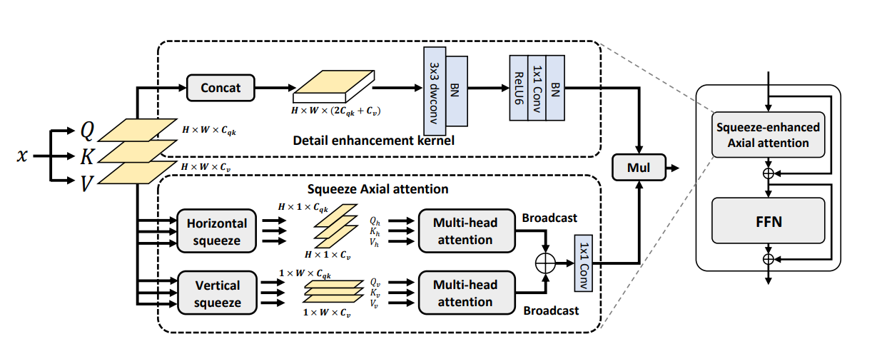

1. Light segmentation head block : The feature after the last fusion block is fed into the proposed segmentation head directly. For fast inference purpose, our light segmentation head consists of two convolution layers, which are followed by a batch normalization layer separately and the feature from the first batch normalization layer is fed into an activation layer.
2. Shared STEM : Stem layers work as a compression mechanism over the initial image. This is done in order to quickly downsample an input image with strided convolutions of quite large kernel size (5x5 or 7x7) so that further layers can effectively do their work with much less computational complexity.

# [**In CNN, are upsampling and transpose convolution the same?**](https://stats.stackexchange.com/questions/252810/in-cnn-are-upsampling-and-transpose-convolution-the-same)

Short Answer: Transpose Convolution is a technique used for Upsampling. There are other techniques as well like Unpooling, Nearest Neighbors etc.

<https://towardsdatascience.com/transposed-convolution-demystified-84ca81b4baba>

Let's first understand where the motivation for such layers come from: e.g. a convolutional autoencoder. You can use a convolutional autoencoder to extract featuers of images while training the autoencoder to reconstruct the original image. (It is an unsupervised method.)

Such an autoencoder has two parts: The encoder that extracts the features from the image and the decoder that reconstructs the original image from these features. The architecture of the encoder and decoder are usually mirrored.

In a convolutional autoencoder, the encoder works with convolution and pooling layers. I assume that you know how these work. The decoder tries to mirror the encoder but instead of "making everything smaller" it has the goal of "making everything bigger" to match the original size of the image.

The opposite of the convolutional layers are **the transposed convolution layers** (also known as deconvolution, but correctly mathematically speaking this is something different). They work with filters, kernels, strides just as the convolution layers but instead of mapping from e.g. 3x3 input pixels to 1 output they map from 1 input pixel to 3x3 pixels. Of course, also backpropagation works a little bit different. ***Transposed convolution* is more involved. It calls tensorflow *conv2d_transpose* function and it has the kernel and is trainable.**

The opposite of the pooling layers are the **upsampling layers** which in their purest form only resize the image (or copy the pixel as many times as needed).  It works by repeating the rows and columns of the input.  keras calls tensorflow “*resize_images”* function, which essentially is an interpolation and not trainable.

A more advanced technique is **unpooling** which resverts maxpooling by remembering the location of the maxima in the maxpooling layers and in the unpooling layers copy the value to exactly this location. To quote “In the convnet, the max pooling operation is non-invertible, however we can obtain an approximate inverse by recording the locations of the maxima within each pooling region in a set of switch variables. In the deconvnet, the unpooling operation uses these switches to place the reconstructions from the layer above into appropriate locations, preserving the structure of the stimulus.”